Промежуточная контрольная работа за 1 полугодие
9 класс (углубленный уровень УМК «English» Афанасьева)
TASK 1. LISTENING
Listen to the text “Abraham Lincoln’s Political Career” and choose the appropriate items to complete the statements below. Write you answers.
Statements | 1 | 2 | 3 | 4 | 5 | 6 | 7
Variants

TASK 2. READING
Read the text “Phillis’ Story” and complete in with the phrases below. There is one phrase you don’t need to use.
- who were intelligent, bright and lively
- before I could say anything
- as Islamic law forbids women
- if I wanted to keep my job
- to buy some food
- a knock at my door
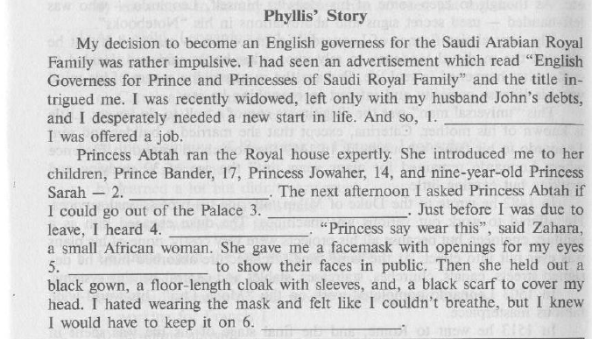
- after an interview

TASK 3. VOCABULARY AND GRAMMAR
- Complete the sentences using the words from the box.

restrict | deals | inherited | establishment | signifies | contemporary | comprise | captured | policy | aware

- The terrorists shot down our plane and __________ the pilot.
- What is the school ___________ on mobile phones in class?
- They were ___________ of the difficulties that might occur.
- The state of Havaii _____________ eight main islands and many smaller ones.
- Charles Darwin was ______________ with Karl Marx.
- The ____________ of diplomatic relations between the two countries improved the situation in that region.
- We _____________ this old house from our grandparents.
- A “P” in a circle ____________ a multi-storey car park.
- Please, ___________ your speech to five minutes.
- I’m looking for a book that __________ with the early history of Russia.

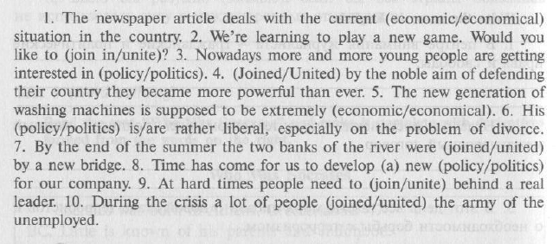
- Choose one of the two words to complete the sentences.
- Write the correct form of the capitalized words.
There is a belief that some jobs suit men better than women and some other jobs are more appropriate for women than for men. Nowadays, women more and more often take jobs that __________________ (TRADITIONAL) were done by men.A lot of women do __________ (DANGER) and difficult jobs, becoming astronauts, pilots, and firefighters.No one is surprised when a girl wants to be a police officer or a train __________(DRIVE). In sports you can see a similar __________(SITUATE). Girls play football, ice hockey, go boxing and do other sports that seem to be __________________(USUAL) for women.But the girls say that it is __________ (EXCITE) and they cannot see any reason why they should not go into the sport they like.
Рекомендуемые критерии оценивания:
Раздел 1: аудирование | Макс.балл – 7 | Итого:  Максимальный балл за работу - 39
Раздел 2: чтение | Макс.балл – 6 | Итого:  Максимальный балл за работу - 39
Раздел 3: Лексика и грамматика | Макс.балл – 26 | Итого:  Максимальный балл за работу - 39

Оценка «5» отлично | 36-39 баллов
Оценка «4» хорошо | 28-35 баллов
Оценка «3» удовлетворительно | 19-27 баллов

